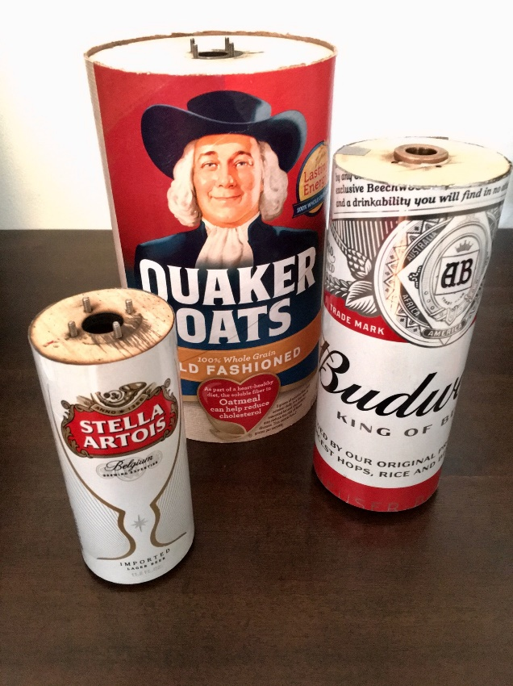

Magnus Effect on Cylindrical Airfoils

Zhangxi Feng, Simon Popecki, James Skinner

ME 646

Professor Todd Gross

Advisor: Samuel Cole

5/9/2017

# Table of Contents

Abstract 2

Introduction 3

Methods 4

Results and Discussion 6

Summary and Conclusion 12

References 14

Appendix A: Tables 15

Appendix B: MATLAB Code 18

# Abstract

Our goal was to evaluate the Magnus Effect on cylindrical airfoils. Using the University of New Hampshire student wind tunnel we tested rotating cylindrical airfoils at different mean wind velocities and rotational speeds. By keeping the velocity in the wind tunnel constant and by changing the RPM of the cylinder, we were able to track trends in the measured lift forces. This test was completed for four different mean wind speeds: 12.0 m/s, 16.4 m/s, 19.8 m/s, 24.0 m/s, and three different cylinder diameters: 2.28”, 3.3”, and 5.05”. We ran an additional test on the smallest diameter cylinder at constant RPM for a wider range of wind speeds between 11.1 m/s and 29.4 m/s to examine the effect of average wind speed on generated lift. Theoretically, we expected to see a linear increase in lift as we increased the wind speed or the RPM, holding other variables constant, and second order growth when increasing the cylinder radius. We found the coefficient of lift plateaus in the range of the tested RPM and the wind speeds. Despite the lift force increasing with radius, the effect of RPM and wind speed depended on the cylinder dimensions where larger radius cylinder generated more lift from higher wind speeds and smaller radius cylinder generated more lift from higher RPMs. Overall, the measured lift forces were lower than the theoretical values. For our additional trial for the smallest cylinder, we found a Reynolds number as high as 1.128x105, which created vortex shedding behind our cylinder and reduced the measured lift force.

# Introduction

A spinning ball will drag more air to one side and create a force from the resulting pressure difference. For example, top spin drags more air to flow below the ball. According to Bernoulli’s principle, faster air flow results in lower pressure, which causes the ball to curve downwards [1]. This is known as the Magnus effect. For cylinders, the Magnus lift force is found using the Kutta-Joukowski equation:

(1)

Where is the Magnus lift force for a cylinder of length in a fluid of density flowing at a velocity . The spin of the cylinder will create the vortex strength found using the radius of the cylinder and angular velocity in rad/s [2]:

(2)

Combining equations 1 and 2 gives equation 3:

(3)

Equation 3 predicts a linear relationship between the angular velocity and the force, a linear relationship between the freestream velocity and the force, and a quadratic relationship between the cylinder radius and the force. This experiment aims to verify the accuracy of the Kutta-Joukouski equation at high rotational speeds by measuring the resulting lift forces on cylindrical airfoils of various radii at various wind speeds.

Since the experiment involves fluid flow over the airfoil, the Reynolds number is also an important concept to check and verify the obtained results by evaluating the flow of air around the cylinders. The equation is given below:

(4)

Where the Reynolds number is found using the fluid density, , velocity, , airfoil characteristic length, , and fluid dynamic viscosity, .

# Methods

Our test was conducted in a subsonic open return wind tunnel. The wind tunnel test section had a cross-sectional area of 18” by 18”. Two cylinders of diameters 2.28” and 3.3” were made from aluminum cans and a third cylinder of diameter 5.05” was made from a cardboard container. The aluminum cylinders had a plywood skeleton inside for stiffness – three wooden disks were spaced evenly inside the can. We press fit disks into the can with shims made from duct tape – this allowed the disks to fall into a balanced position after roughly 20 seconds of run time at 3,000 RPM, helping to balance the airfoils. One disk was in the middle of the can, and the other two disks were placed at the ends of the cylinder, and were attached to plain bearings driven by a Mega Motor ACn 16/15/4 brushless motor. The disks were balanced by drilling holes on opposite sides of missing material (low quality plywood). The motor was driven by a Thunderbird 18 Electronic Speed Controller connected to a Spektrum 2.4 GHz receiver. The cylinders had lengths of 5.125”, 6.938”, and 9” in order of increasing diameter. The cylinder was situated near the middle of the cross-section to minimize the effects of boundary layers from the walls. The setup was loaded in cantilever on a steel tube. The tube remained stationary while the airfoils rotated on it.

The steel tube was supported by an AFA2 force balance to measure lift force. The force balance had a resolution of 0.01 N and an accuracy of ± 0.2 N. We used a handheld tachometer to measure the RPM of the rotating cylinder with a resolution of 10 RPM and a fluctuation accuracy of about ± 200 RPM. Any dimension under 5” was measured with calipers. The diameter of the small and medium radius cylinders were measured to 0.001” or better. The lengths and the diameter of the large cylinder had a resolution of 0.05” (measured with machinist’s ruler). A pitot-static tube was used to measure the static and stagnation pressures in the wind tunnel, which were then used to calculate the wind speed. The speed was controlled by turning a dial controlling wind tunnel motor speed until the Pitot tube readings reached the desired level. The tube readings had a resolution of ± 0.05” of water (half the smallest tick spacing). We assumed the air density uncertainty from barometric pressure reading was negligible and the water density had an uncertainty of 0.05 kg/m3, the errors for wind speeds were propagated to be:

Where is the dynamic pressure found from the difference of static and stagnation pressures from the tube readings. The errors in the 4 wind speeds were found to be (12.0 ± 1.2) m/s (10%), (16.4 ± 0.9) m/s (5.4%), (19.8 ± 0.7) m/s (3.7%), and (24.0 ± 0.6) m/s (2.5%).

(5)

We conducted four trials for each cylinder at the each of the wind speeds. For each trial, the cylinders were rotated at three different RPMs. The large cylinder was run between 3500 RPM and 6000 RPM. The other two cylinders covered a range from 3000 RPM to 6000 RPM. Due to the accuracy of the tachometer and the fluctuating nature of the rotating cylinder, it was ineffective to maintain the same RPM across the trials. At the RPMs in the experiment, the expected forces from equation 3 range from 3.1 N at smallest diameter and slowest wind speed to 98 N at the largest diameter and fastest wind speed. 200 RPM difference would result in 4% to 6% error, which suggested the RPMs can be treated as equal when evaluating the effect of wind speed at constant RPM.

# Results and Discussion

Figure 1 below shows the decreasing lift force trend for increasing wind speed with the smallest diameter (Stella) cylinder at a constant 3760 RPM.

Figure 1 Smallest diameter cylinder measured lift force by increasing wind speed at constant RPM



This result shows the lift force decreased as the wind speed increased. This is the opposite of our predicted positive linear relationship. The wide confidence intervals suggest this trial had a large uncertainty therefore it was inconclusive in determining the effect of wind speed at a higher RPM on the lift force. To investigate for a cause of these measurements, we calculated the Reynolds numbers to be up to 1.12 x 105, where the Kármán vortex street (vortex shedding) of a cylinder is fully turbulent [3]. The Strouhal numbers for all trials were found to be 0.198, which translates to vortex frequencies of 18.53 Hz to 100.57 Hz (see tables Table A5 to Table A7). Instead of the air forcing the cylinder up as a result of the high pressure in the wake, the wake now oscillates and induces a force on either side of the cylinder. A still visualization of the flow separation due to the high Reynolds number and oscillating wake is shown in figure 2 above.



Figure 2 Visualization of the Kármán vortex streets for a stationary cylinder, from: https://disc.gsfc.nasa.gov/education-and-outreach/additional/science-focus/ocean-color/vonKarman_vortices.shtml

The result of varying RPM at a constant wind speed of 16.4 m/s for the smallest diameter cylinder is shown in figure 3 and the result for the largest diameter (Quaker Oats) is shown in figure 4. The measured lift forces were significantly smaller than expected. The other trials produced similar results. These results are likely also caused by the flow separation past the cylinder and the shifting of wake due to rotation.

Figure 3 Smallest diameter cylinder measured vs predicted lift force at constant wind speed across the same RPM range



figure 5 shows the results from a study done by Tokumaru and Dimotakis on the effect of changing RPM on the lift coefficient at various Reynolds numbers and cylinder dimensions. is the tangential velocity found from RPM and the cylinder radius normalized by wind speed with the square symbols representing the case of largest cylinder span to diameter ratio, , of 18.7 and a Reynolds number of 3.8 x 103, the circle and other illegible symbols representing the case of ratio of 13.3 and various Reynolds numbers, and the dash line representing the smallest ratio of 4.7 and a Reynolds number of 5.2 x 104. The figure suggests there exists a maximum coefficient of lift for each geometry and wind speed. Upon reaching a sufficiently high RPM, the lift coefficient begins to plateau. The maximum lift coefficient also decreases with smaller ratio [4].



Figure 4 Largest diameter cylinder measured vs predicted lift force at constant wind speed across the same RPM range

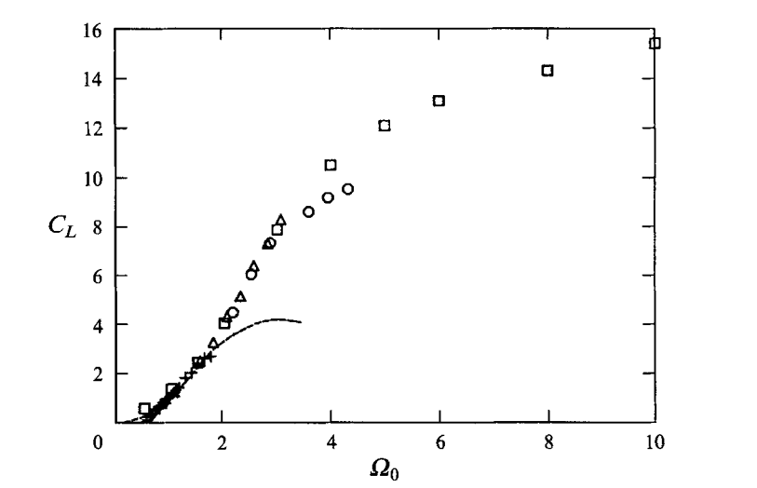

Figure 5 Lift coefficient versus normalized transverse velocities for various cylinders at various Reynolds numbers

Our experiment can be best predicted from the dash line since our cylinders have ratios of 2.24, 2.1, and 1.8 from smallest to largest diameters respectively. The dash line in Figure 5 shows the plateau region of is approximately between to . Shown in Figure 6 below, our experiment’s lift coefficient plateau region approximately ranges from to with respect to slowest speed on smallest diameter to the fastest speed on the largest diameter. Since our confidence intervals shown in Figure 1 suggested our data may be inconclusive towards a non-linear relationship, the curve shown is strictly a visual aid to show the plateau in the lift coefficient at higher values of .



Figure Lift coefficient versus normalized rotation speed plot of our measured data with a strictly visual suggested relationship curve (R2 = 0.39)

We additionally evaluated the resulting coefficient of lift and plotted them against the theoretical values in figure 7 using the following equation:

(6)

Where the represents the lift per unit span of the cylinder. The below data shows the same downward trend in coefficient of lift as the velocity of the wind tunnel increase as expected given equation 6. Again, the difference in magnitude is expected given the assumed flow separation from the high Reynold’s number at the wind speeds is negatively effecting the lift due to the developed flow separation.

Figure 7 Coefficient of lift for the smallest cylinder for range of RPM at constant wind speed, where blue represents 12.0 m/s, red represents 16.4 m/s, black represents 19.8 m/s, and cyan represents 24.0 m/s



The representative data below for the medium (Bud Heavy) cylinder at constant wind speed and a range of high RPM is shown in figure 8 in the next page. The medium cylinder caused concern when conducting trials at the various wind speeds in the wind tunnel for the range of RPM. The cylinder became unbalanced and caused concerning vibration on the experimental set-up which was causing the AFA-2 force balance to not operate properly which began to display erratic and unreliable results. Later investigation revealed the medium cylinder became unbalanced as a result of the wooden disk in the center of the cylinder sliding down to one end of the airfoil while spinning inside the wind tunnel during testing. To adjust the center disk we would need to remove the end caps of the cylinder and then reset all disks within the cylinder as described in the Methods section. We evaluated that disassembling the cylinder’s supports could have led to more problems with the cylinder. We decided to continue our experiment under the time constraint, taking the data we had already collected, and continued on to our next cylinder.



Figure Large diameter cylinder lift force versus RPM at constant wind speeds



Figure 9 Medium sized cylinder measured vs predicted lift force at constant wind speed across the same RPM range



Figure Small diameter cylinder lift force versus RPM at constant wind speeds

Figures 9 and 10 showed the effect of RPM at constant wind speed for the large and the small diameter cylinders. The results showed that the larger diameter cylinder had increasing lift force with increasing wind speed but the small diameter cylinder had decreasing lift force with wind speed overall. This suggest that larger cylinders with higher ratios would benefit better from the Magnus effect, which agrees with the results from the research done by Tokumaru and Dimotakis. Figures 9 and 10 also showed that increasing RPM at constant wind speeds would generate more lift for smaller diameter cylinders than larger diameter cylinders, opposite of the effect of increasing wind speed at constant RPM.

# Summary and Conclusion

The purpose of this experiment was to investigate the effect of high RPM airfoils with regards to lift generated via the Magnus effect. We made predictions for the forces we expected to see at various RPM ranges based on possible choices for cylinder dimensions. Airfoils were designed such that lift would not exceed 20 N, but would be greater than 1 N so the force balance could measure the data with good signal to noise ratio. Experimentation revealed measured lift forces much lower than what was predicted, as well as unexpected vortex shredding. In some cases, increasing the wind speed decreased the measured lift – contrary to the expectations derived from our equations.

The rotational speeds of the airfoils in this experiment were generally higher than the rotational speeds found in other research reports partially due to the difficulty in balancing airfoils at these speeds, and mostly due to lift force plateauing as RPM exceeds beyond a limit. The resulting data from the experiment suggested that coefficient of lift increased with rotational speed up to a ceiling that also depends on the cylinder dimensions. These results are consistent with Tokumaru and Dimotakis research.

Our experiment also showed that larger cylinders generate more lift forces at higher wind speeds due to the Magnus effect and the smaller diameter cylinders would likely generate less lift force at higher wind speeds as a result of a lower span to diameter ratio, which affected the effective lift area. Furthermore, increasing RPM increased the generated lift forces for smaller cylinders but marginally affected the larger diameter cylinder.

# References

|  |  |
| --- | --- |
| [1] | R. K. G. Kobes, "Bernoulli's Principle," 29 September 1999. [Online]. Available: http://theory.uwinnipeg.ca/mod_tech/node68.html. [Accessed 6 May 2017]. |
| [2] | N. Hall, "Lift of Rotating Cylinder," NASA, 5 May 2015. [Online]. Available: https://www.grc.nasa.gov/www/k-12/airplane/cyl.html. [Accessed 30 4 2017]. |
| [3] | S. Bengt, "Tubes, Crossflow over," Thermopedia, 16 March 2011. [Online]. Available: http://www.thermopedia.com/content/1216/. [Accessed 30 April 2017]. |
| [4] | P. a. D. P. Tokumaru, "The Lift of a Cylinder Executing Rotary Motions in a Uniform Flow," Cambridge University Press, Cambridge, UK, 1992. |

# Appendix A: Tables

Table A1 Smallest diameter cylinder experiment data

|  |  |  |  |  |  |  |
| --- | --- | --- | --- | --- | --- | --- |
| Stella |  |  |  |  |  |  |
| P1 (inH2O) | P2 (inH2O) | Delta h (m) | Wind Speed (m/s) | RPM | Lift (N) | Test |
| 1.65 | 1.3 | 0.00889 | 12.00973309 | 3100 | 0.5 | **TRIAL 1** |
|  |  |  |  | 4060 | 1.45 |  |
|  |  |  |  | 6000 | 1.96 |  |
| 2 | 1.35 | 0.01651 | 16.36650742 | 3024 | 1.25 | **TRIAL 2** |
|  |  |  |  | 4130 | 1.48 |  |
|  |  |  |  | 5960 | 2.28 |  |
| 2.45 | 1.5 | 0.02413 | 19.78614266 | 2950 | 1.35 | **TRIAL 3** |
|  |  |  |  | 3930 | 1.27 |  |
|  |  |  |  | 5950 | 2.31 |  |
| 3 | 1.6 | 0.03556 | 24.01946618 | 2800 | 1.43 | **TRIAL 4** |
|  |  |  |  | 4000 | 1.17 |  |
|  |  |  |  | 5870 | 2.11 |  |

Table A2 Medium diameter cylinder experiment data

|  |  |  |  |  |  |  |
| --- | --- | --- | --- | --- | --- | --- |
| Budweiser |  |  |  |  |  |  |
| P1 (inH2O) | P2 (inH2O) | Delta h (m) | Wind Speed (m/s) | RPM | Lift (N) |  |
| 1.65 | 1.3 | 0.00889 | 12.00973309 | 3200 | 2.3 | **TRIAL 1** |
|  |  |  |  | 4940 | 3.17 |  |
|  |  |  |  | 5800 | 1.65 |  |
| 2 | 1.35 | 0.01651 | 16.36650742 | * | * | **TRIAL 2\*** |
|  |  |  |  | * | * |  |
|  |  |  |  | * | * |  |
| 2.45 | 1.5 | 0.02413 | 19.78614266 | 3291 | 10.13 | **TRIAL 3** |
|  |  |  |  | 4700 | 21.92 |  |
|  |  |  |  | 5844 | 13.91 |  |
| 3 | 1.6 | 0.03556 | 24.01946618 | 3100 | 10.25 | **TRIAL 4** |
|  |  |  |  | 4860 | 13.11 |  |
|  |  |  |  | 5916 | 8.97 |  |

Table A3 Largest diameter cylinder experiment data

|  |  |  |  |  |  |  |
| --- | --- | --- | --- | --- | --- | --- |
| Oats |  |  |  |  |  |  |
| P1 (inH2O) | P2 (inH2O) | Delta h (m) | Wind Speed (m/s) | RPM | Lift (N) |  |
| 1.65 | 1.3 | 0.00889 | 12.00973309 | 3720 | 3.72 | **TRIAL 1** |
|  |  |  |  | 4560 | 3.14 |  |
|  |  |  |  | 5560 | 4.35 |  |
| 2 | 1.35 | 0.01651 | 16.36650742 | 3660 | 6 | **TRIAL 2** |
|  |  |  |  | 4470 | 4.97 |  |
|  |  |  |  | 5630 | 5.26 |  |
| 2.45 | 1.5 | 0.02413 | 19.78614266 | 3675 | 8.42 | **TRIAL 3** |
|  |  |  |  | 4050 | 7.25 |  |
|  |  |  |  | 5500 | 7.67 |  |
| 3 | 1.6 | 0.03556 | 24.01946618 | 3000 | 10.6 | **TRIAL 4** |
|  |  |  |  | 3160 | 15.5 |  |
|  |  |  |  | 5200 | 10.43 |  |

Table A4 Smallest diameter cylinder high wind speed experiment data

|  |  |  |  |  |  |
| --- | --- | --- | --- | --- | --- |
| P1 (inH2O) | P2 (inH2O) | Delta h (m) | Wind Speed (m/s) | Lift (N) | RPM |
| 1.5 | 1.2 | 0.00762 | 11.11885229 | 0.67 | 3760 |
| 2 | 1.35 | 0.01651 | 16.36650742 | 0.61 | - |
| 2.5 | 1.5 | 0.0254 | 20.30015404 | 0.5 | - |
| 3 | 1.65 | 0.03429 | 23.58664756 | 0.4 | - |
| 3.5 | 1.8 | 0.04318 | 26.46816261 | 0.36 | - |
| 4 | 1.9 | 0.05334 | 29.41771802 | 0.47 | 3760 |

Table A5 Small diameter cylinder wind speed and corresponding Reynolds and Strouhal numbers

|  |  |  |  |  |
| --- | --- | --- | --- | --- |
| **Stella** | | | | |
| **Wind Speed (m/s)** | **Reynolds Number** | **Strouhal Number** | **Vortex Frequency (Hz)** |
| 12.0 | 4.60E+04 | 0.1979 | 41.04 |
| 16.4 | 6.27E+04 | 0.1979 | 55.94 |
| 19.8 | 7.58E+04 | 0.1979 | 67.63 |
| 20.0 | 9.21E+04 | 0.1980 | 82.11 |
| 29.4 | 1.13E+05 | 0.1980 | 100.57 |

Table A6 Medium diameter cylinder wind speed and corresponding Reynolds and Strouhal numbers

|  |  |  |  |  |
| --- | --- | --- | --- | --- |
| **Budweiser** | | | | |
| **Wind Speed (m/s)** | **Reynolds Number** | **Strouhal Number** | **Vortex Frequency (Hz)** |
| 12.0 | 6.66E+04 | 0.1979 | 23.36 |
| 16.4 | 9.08E+04 | 0.1980 | 38.65 |
| 19.8 | 1.10E+05 | 0.1980 | 46.73 |
| 20.0 | 1.33E+05 | 0.1980 | 56.73 |

Table A7 Largest diameter cylinder wind speed and corresponding Reynolds and Strouhal numbers

|  |  |  |  |  |
| --- | --- | --- | --- | --- |
| **Quaker Oats** | | | | |
| **Wind Speed (m/s)** | **Reynolds Number** | **Strouhal Number** | **Vortex Frequency (Hz)** |
|  |  |  |  |
| 12.0 | 1.02E+05 | 0.1980 | 18.53 |
| 16.4 | 1.39E+05 | 0.1980 | 25.26 |
| 19.8 | 1.68E+05 | 0.1980 | 30.54 |
| 20.0 | 2.04E+05 | 0.1980 | 37.07 |

# Appendix B: MATLAB Code

Overall experiment variables 2

1. Effect of RPM on lift force at constant wind speed for each airfoil 2

stella - r = 57.91/2000; % radius in [m] 2

Bud - r = 83.82/2000; % radius in [m] 6

Quaker - r = 128.27/2000; % radius in [m] 9

comparison to theory completed, looking for patterns within the collected 13

2. Effect of changing wind speed on lift force 15

Calculating Reynolds number for 3 cylinders and all 4 speeds 15

Plotting all the data 16

fitting the wind speed data 19

3. Effect of increasing wind speed on a fixed RPM on the lift force 21

Plotting and fitting 21

Error Analysis 21

Plotting everythang 22

Calculateing the Coefficient of Lift 23

Plot Theoretical Coefficent of Lift 24

Calculateing the Coefficient of Lift 26

Plot for Experimental Coefficient of Lift 27

Experimental vs Theoretical CL 30

Vortex Shedding 31

Misc Info 32

clear all;  
close all;  
clc;  
% Magnus Effect Overview  
% Variables:  
% FL: lift force - measured by force balance  
% rho: air density - calculated from the day's atmospheric pressure  
% v: air speed - calculated using pitot tube  
% G: vortex strength - found using G = 2*pi*r^2*omega  
% r: cylinder radius  
% omega: RPM in rad/s  
% L: length of the cylinder  
% FL = rho*v*G*L = rho*v*4*pi^2*r^2*omega*L = rho*v*4*pi^2*r^2*omega*L  
%  
% Topics to analyze:  
% 1. Effect of changing RPM on lift force at constant wind speed  
% - expect linear relationship  
% 2. Effect of changing wind speed on lift force at constant RPM  
% - expect linear relationship  
% 3. Effect of linearly increasing wind speed on lift force  
% - expect linear relationship  
  
%%%%%%%%%%%%%%%%%%%%%%%%%%%%%%%%%%%%%%%%%%%%%%%%%%%%%%%%%%  
% Authors: Feng, Zhangxi; Popecki, Simon; Skinner, James %  
% Course: ME646 %  
% Project: Cylindrical Airfoil Magnus Effect %  
% Date: May 1, 2017 %  
%%%%%%%%%%%%%%%%%%%%%%%%%%%%%%%%%%%%%%%%%%%%%%%%%%%%%%%%%%

## Overall experiment variables

See attached excel sheet for the experiment data windspeeds from pitot tube readings:

speed4 = 24.01946618; % [m/s]  
speed3 = 19.78614266;  
speed2 = 16.36650742;  
speed1 = 12.00973309;  
airrho = 1.2093;  
% [kg/m^3] from ideal gas law and the barometric pressure of the day

## 1. Effect of RPM on lift force at constant wind speed for each airfoil

## stella - r = 57.91/2000; % radius in [m]

rStella = 57.91/2000;  
LStella = 0.130175; % length of stella in meters  
forceStella = [0.5,1.45,1.96;...  
 1.25,1.48,2.28;...  
 1.35,1.27,2.31;...  
 1.43,1.17,2.11];  
RPMStella = [3100,4060,6000;...  
 3024,4130,5960;...  
 2950,3930,5950;...  
 2800,4000,5870]; % convert from [rpm] to [rps]  
% expected relationship  
RPMMagnusStella = (2800:100:6000); % [rpm]  
  
% FL = 4*pi^2*r^2*rho*v*omega*L  
FLStella4 = 4*pi^2*rStella^2*airrho*speed4.*RPMMagnusStella/60*LStella;  
FLStella3 = 4*pi^2*rStella^2*airrho*speed3.*RPMMagnusStella/60*LStella;  
FLStella2 = 4*pi^2*rStella^2*airrho*speed2.*RPMMagnusStella/60*LStella;  
FLStella1 = 4*pi^2*rStella^2*airrho*speed1.*RPMMagnusStella/60*LStella;  
  
% polyfitting data to line  
% speed4  
stellaFit4 = polyfit(RPMStella(4,:),forceStella(4,:),1);  
stellaFit4x = 2800:(5870-2800)/1000:5870;  
stellaFit4y = stellaFit4x*stellaFit4(1) + stellaFit4(2);  
% speed3  
stellaFit3 = polyfit(RPMStella(3,:),forceStella(3,:),1);  
stellaFit3x = 2950:(5950-2950)/1000:5950;  
stellaFit3y = stellaFit3x*stellaFit3(1) + stellaFit3(2);  
% speed2  
stellaFit2 = polyfit(RPMStella(2,:),forceStella(2,:),1);  
stellaFit2x = 3024:(5960-3024)/1000:5960;  
stellaFit2y = stellaFit2x*stellaFit2(1) + stellaFit2(2);  
% speed1  
stellaFit1 = polyfit(RPMStella(1,:),forceStella(1,:),1);  
stellaFit1x = 3100:(6000-3100)/1000:6000;  
stellaFit1y = stellaFit1x*stellaFit1(1) + stellaFit1(2);  
  
% speed4 plots  
figure;  
hold on;  
plot(RPMMagnusStella,FLStella4,'r--');  
plot(RPMStella(4,:),forceStella(4,:),'bx',stellaFit4x,stellaFit4y,'b');  
xlabel('Cylinder Rotation Speed [RPM]');  
ylabel('Lift Force (N)');  
title('Stella Cylinder Lift Force vs. RPM at 24.0 m/s');  
l = legend('Magnus Predicted','Experiment Data','Experiment Fit','Location','best');  
%set(l,'FontSize',12);  
  
% speed3 plots  
figure;  
hold on;  
plot(RPMMagnusStella,FLStella3,'r--');  
plot(RPMStella(3,:),forceStella(3,:),'bx',stellaFit3x,stellaFit3y,'b');  
xlabel('Cylinder Rotation Speed [RPM]');  
ylabel('Lift Force (N)');  
title('Stella Cylinder Lift Force vs. RPM at 19.8 m/s');  
l = legend('Magnus Predicted','Experiment Data','Experiment Fit','Location','best');  
set(l,'FontSize',12);  
  
% speed2 plots  
figure;  
hold on;  
plot(RPMMagnusStella,FLStella2,'r--');  
plot(RPMStella(2,:),forceStella(2,:),'bx',stellaFit2x,stellaFit2y,'b');  
xlabel('Cylinder Rotation Speed [RPM]');  
ylabel('Lift Force (N)');  
title('Stella Cylinder Lift Force vs. RPM at 16.4 m/s');  
l = legend('Magnus Predicted','Experiment Data','Experiment Fit','Location','best');  
%set(l,'FontSize',12);  
  
% speed1 plots  
figure;  
hold on;  
plot(RPMMagnusStella,FLStella1,'r--');  
plot(RPMStella(1,:),forceStella(1,:),'bx',stellaFit1x,stellaFit1y,'b');  
xlabel('Cylinder Rotation Speed [RPM]');  
ylabel('Lift Force (N)');  
title('Stella Cylinder Lift Force vs. RPM at 12.0 m/s');  
l = legend('Magnus Predicted','Experiment Data','Experiment Fit','Location','best');  
%set(l,'FontSize',12);

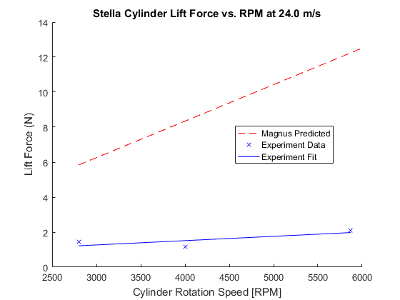

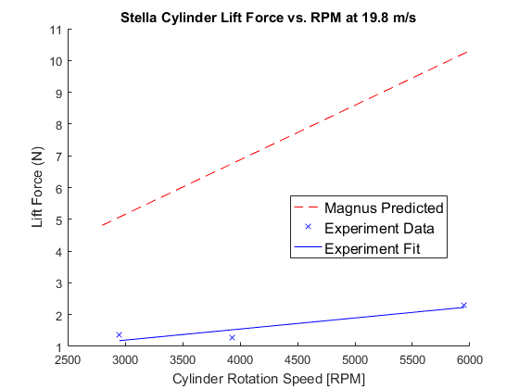

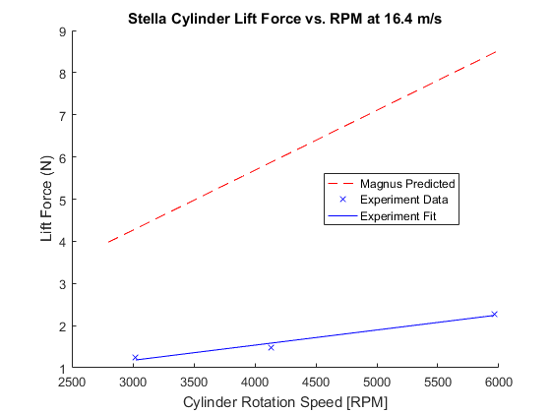

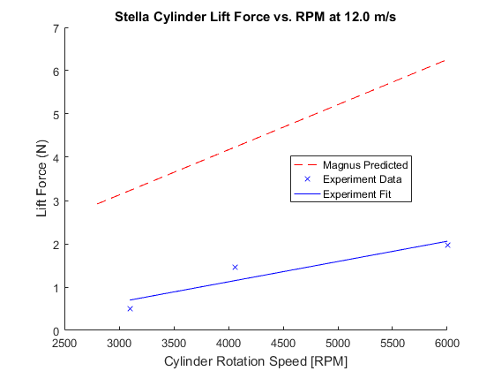

## Bud - r = 83.82/2000; % radius in [m]

rBud = 83.82/2000; % finding radius from diamter in [mm] to [m]  
LBud = 0.1762125; % length of bud cylinder in meters  
forceBud = [2.3,3.17,1.65;...  
 0,0,0;...  
 10.13,21.92,13.91;...  
 10.25,13.11,8.97];  
RPMBud = [3200,4940,5800;...  
 0,0,0;...  
 3291,4700,5844;...  
 3100,4860,5916]; % convert from [rpm] to [rps]  
% expected relationship  
RPMMagnusBud = (2500:100:6000); % [rpm]  
  
% FL = 4*pi^2*r^2*rho*v*omega*L  
FLBud4 = 4*pi^2*rBud^2*airrho*speed4.*RPMMagnusBud/60*LBud;  
FLBud3 = 4*pi^2*rBud^2*airrho*speed3.*RPMMagnusBud/60*LBud;  
FLBud2 = 4*pi^2*rBud^2*airrho*speed2.*RPMMagnusBud/60*LBud;  
FLBud1 = 4*pi^2*rBud^2*airrho*speed1.*RPMMagnusBud/60*LBud;  
  
% polyfitting data to line  
% speed4  
budFit4 = polyfit(RPMBud(4,:),forceBud(4,:),1);  
budFit4x = 3100:(5916-3100)/1000:5916;  
budFit4y = budFit4x*budFit4(1) + budFit4(2);  
% speed3  
budFit3 = polyfit(RPMBud(3,:),forceBud(3,:),1);  
budFit3x = 3291:(5844-3291)/1000:5844;  
budFit3y = budFit3x*budFit3(1) + budFit3(2);  
% speed1  
budFit1 = polyfit(RPMBud(1,:),forceBud(1,:),1);  
budFit1x = 3200:(5800-3200)/1000:5800;  
budFit1y = budFit1x*budFit1(1) + budFit1(2);  
  
% speed4 plots  
figure;  
hold on;  
plot(RPMMagnusBud,FLBud4,'r--');  
plot(RPMBud(4,:),forceBud(4,:),'bx',budFit4x,budFit4y,'b');  
xlabel('Cylinder Rotation Speed [RPM]');  
ylabel('Lift Force (N)');  
title('Bud Heavy Cylinder Lift Force vs. RPM at 24.0 m/s');  
l = legend('Magnus Predicted','Experiment Data','Experiment Fit','Location','best');  
%set(l,'FontSize',12);  
  
% speed3 plots  
figure;  
hold on;  
plot(RPMMagnusBud,FLBud3,'r--');  
plot(RPMBud(3,:),forceBud(3,:),'bx',budFit3x,budFit3y,'b');  
xlabel('Cylinder Rotation Speed [RPM]');  
ylabel('Lift Force (N)');  
title('Bud Heavy Lift Force vs. RPM at 19.8 m/s');  
l = legend('Magnus Predicted','Experiment Data','Experiment Fit','Location','best');  
%set(l,'FontSize',12);  
  
% speed2 plot for Bud does not exist  
  
% speed1 plots  
figure;  
hold on;  
plot(RPMMagnusBud,FLBud1,'r--');  
plot(RPMBud(1,:),forceBud(1,:),'bx',budFit1x,budFit1y,'b');  
xlabel('Cylinder Rotation Speed [RPM]');  
ylabel('Lift Force (N)');  
title('Bud Heavy Cylinder Lift Force vs. RPM at 12.0 m/s');  
l = legend('Magnus Predicted','Experiment Data','Experiment Fit','Location','best');  
%set(l,'FontSize',12);

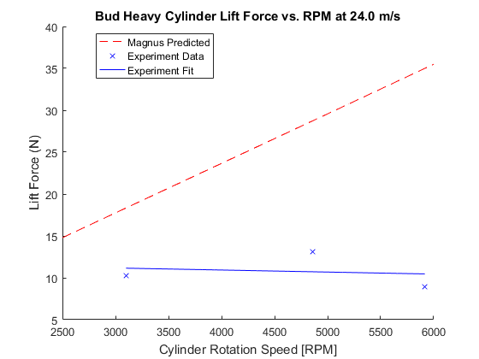

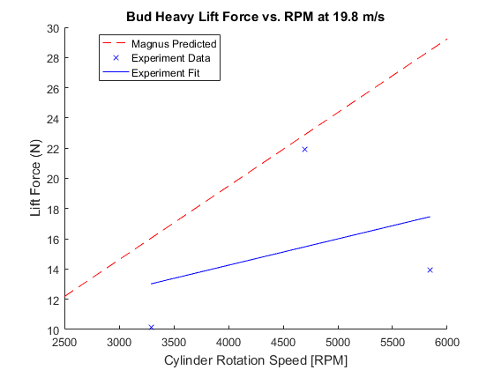

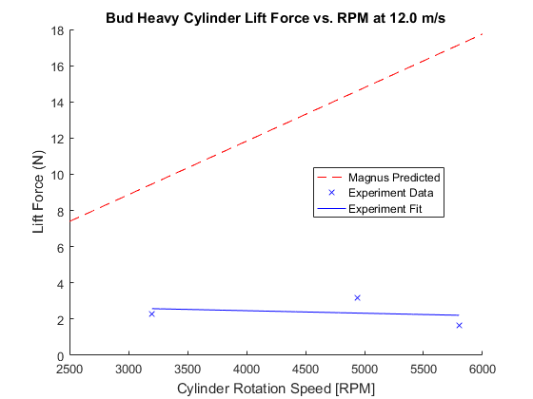

## Quaker - r = 128.27/2000; % radius in [m]

rQuaker = 128.27/2000;  
LQuaker = 0.2286; % length of quaker oats cylinder in meters  
forceQuaker = [3.72,3.14,4.35;...  
 6,4.97,5.26;...  
 8.42,7.25,7.67;...  
 10.6,15.5,10.43];  
RPMQuaker = [3720,4560,5560;...  
 3660,4470,5630;...  
 3675,4050,5500;...  
 3000,3160,5200]; % convert from [rpm] to [rps]  
% expected relationship  
RPMMagnusQuaker = (2500:100:6000); % [rpm]  
  
% FL = 4*pi^2*r^2*rho*v*omega*L  
FLQuaker4 = 4*pi^2*rQuaker^2*airrho*speed4.*RPMMagnusQuaker/60*LQuaker;  
FLQuaker3 = 4*pi^2*rQuaker^2*airrho*speed3.*RPMMagnusQuaker/60*LQuaker;  
FLQuaker2 = 4*pi^2*rQuaker^2*airrho*speed2.*RPMMagnusQuaker/60*LQuaker;  
FLQuaker1 = 4*pi^2*rQuaker^2*airrho*speed1.*RPMMagnusQuaker/60*LQuaker;  
  
% polyfitting data to line  
% speed4  
quakerFit4 = polyfit(RPMQuaker(4,:),forceQuaker(4,:),1);  
quakerFit4x = 3000:(5200-3000)/1000:5200;  
quakerFit4y = quakerFit4x*quakerFit4(1) + quakerFit4(2);  
% speed3  
quakerFit3 = polyfit(RPMQuaker(3,:),forceQuaker(3,:),1);  
quakerFit3x = 3675:(5500-3675)/1000:5500;  
quakerFit3y = quakerFit3x*quakerFit3(1) + quakerFit3(2);  
% speed2  
quakerFit2 = polyfit(RPMQuaker(2,:),forceQuaker(2,:),1);  
quakerFit2x = 3660:(5630-3660)/1000:5630;  
quakerFit2y = quakerFit2x*quakerFit2(1) + quakerFit2(2);  
% speed1  
quakerFit1 = polyfit(RPMQuaker(1,:),forceQuaker(1,:),1);  
quakerFit1x = 3720:(5560-3720)/1000:5560;  
quakerFit1y = quakerFit1x*quakerFit1(1) + quakerFit1(2);  
  
% speed4 plots  
figure;  
hold on;  
plot(RPMMagnusQuaker,FLQuaker4,'r--');  
plot(RPMQuaker(4,:),forceQuaker(4,:),'bx',quakerFit4x,quakerFit4y,'b');  
xlabel('Cylinder Rotation Speed [RPM]');  
ylabel('Lift Force (N)');  
title('Quaker Oats Cylinder Lift Force vs. RPM at 24.0 m/s');  
l = legend('Magnus Predicted','Experiment Data','Experiment Fit','Location','best');  
%set(l,'FontSize',12);  
  
% speed3 plots  
figure;  
hold on;  
plot(RPMMagnusQuaker,FLQuaker3,'r--');  
plot(RPMQuaker(3,:),forceQuaker(3,:),'bx',quakerFit3x,quakerFit3y,'b');  
xlabel('Cylinder Rotation Speed [RPM]');  
ylabel('Lift Force (N)');  
title('Quaker Oats Cylinder Lift Force vs. RPM at 19.8 m/s');  
l = legend('Magnus Predicted','Experiment Data','Experiment Fit','Location','best');  
%set(l,'FontSize',12);  
  
% speed2 plots  
figure;  
hold on;  
plot(RPMMagnusQuaker,FLQuaker2,'r--');  
plot(RPMQuaker(2,:),forceQuaker(2,:),'bx',quakerFit2x,quakerFit2y,'b');  
xlabel('Cylinder Rotation Speed [RPM]');  
ylabel('Lift Force (N)');  
title('Quaker Oats Cylinder Lift Force vs. RPM at 16.4 m/s');  
l = legend('Magnus Predicted','Experiment Data','Experiment Fit','Location','best');  
%set(l,'FontSize',12);  
  
% speed1 plots  
figure;  
hold on;  
plot(RPMMagnusQuaker,FLQuaker1,'r--');  
plot(RPMQuaker(1,:),forceQuaker(1,:),'bx',quakerFit1x,quakerFit1y,'b');  
xlabel('Cylinder Rotation Speed [RPM]');  
ylabel('Lift Force (N)');  
title('Quaker Oats Cylinder Lift Force vs. RPM at 12.0 m/s');  
l = legend('Magnus Predicted','Experiment Data','Experiment Fit','Location','best');  
%set(l,'FontSize',12);

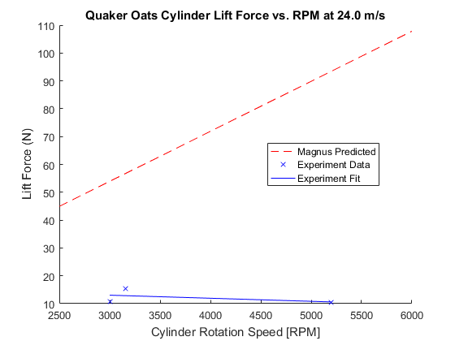

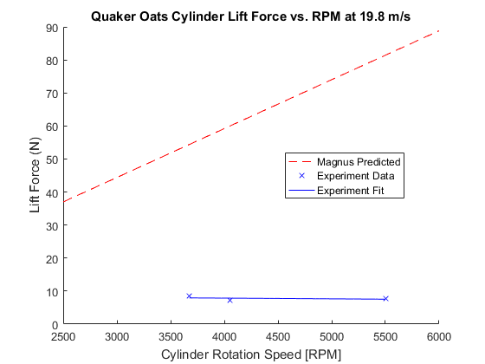

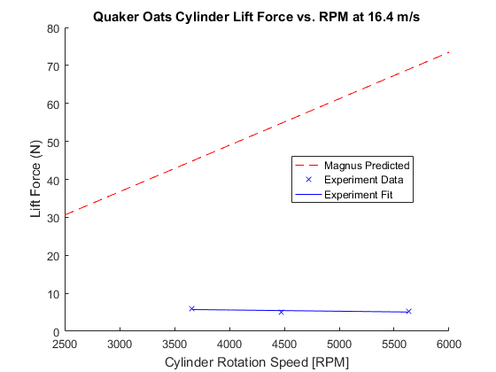

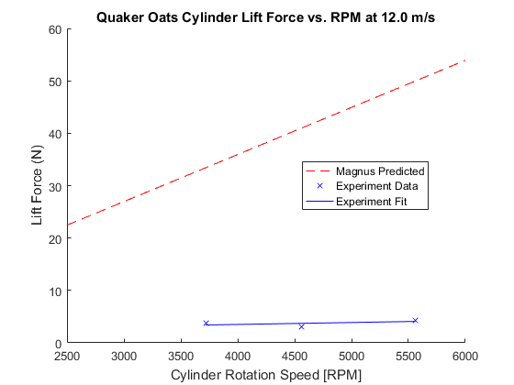

## comparison to theory completed, looking for patterns within the collected

data plot of just the experimental data quaker oats cylinder

figure;  
hold on;  
plot(RPMQuaker(4,:),forceQuaker(4,:),'--*');  
plot(RPMQuaker(3,:),forceQuaker(3,:),'--x');  
plot(RPMQuaker(2,:),forceQuaker(2,:),'--d');  
plot(RPMQuaker(1,:),forceQuaker(1,:),'--s');  
grid on;  
xlabel('Rotation Speed (RPM)');  
ylabel('Life Force (N)');  
title({'Measured Lift Force of Quaker Oats Cylinder vs. RPM','at Constant Wind Speeds'});  
l = legend('Location','best','24.0 m/s','19.8 m/s','16.4 m/s','12.0 m/s');  
%set(l,'FontSize',12);  
  
% Bud Heavy cylinder  
figure;  
hold on;  
plot(RPMBud(4,:),forceBud(4,:),'--*');  
plot(RPMBud(3,:),forceBud(3,:),'--x');  
plot(RPMBud(1,:),forceBud(1,:),'--s');  
grid on;  
xlabel('Rotation Speed (RPM)','FontSize',12);  
ylabel('Life Force (N)','FontSize',12);  
title({'Measured Lift Force of Bud Heavy Cylinder vs. RPM','at Constant Wind Speeds'});  
l = legend('Location','northeast','24.0 m/s','19.8 m/s','12.0 m/s');  
%set(l,'FontSize',12);  
text(3150,24,'16.4 m/s wind speed has no data','FontSize',12);  
  
% Stella cylinder  
figure;  
hold on;  
plot(RPMStella(4,:),forceStella(4,:),'--*');  
plot(RPMStella(3,:),forceStella(3,:),'--x');  
plot(RPMStella(2,:),forceStella(2,:),'--d');  
plot(RPMStella(1,:),forceStella(1,:),'--s');  
grid on;  
xlabel('Rotation Speed (RPM)');  
ylabel('Life Force (N)');  
title({'Measured Lift Force of Stella Cylinder vs. RPM','at Constant Wind Speeds'});  
l = legend('Location','best','24.0 m/s','19.8 m/s','16.4 m/s','12.0 m/s');  
%set(l,'FontSize',12);

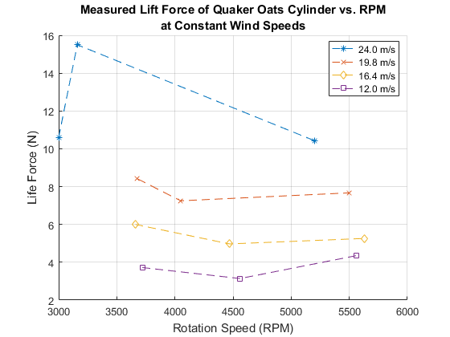

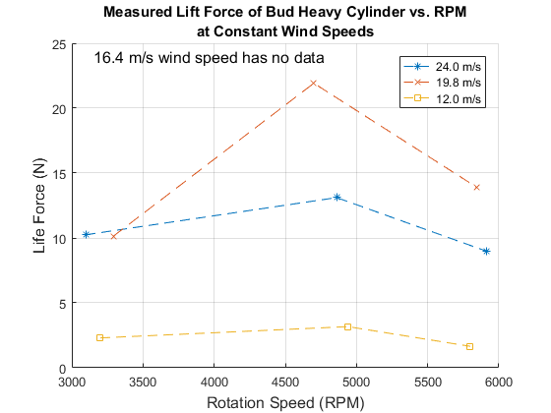

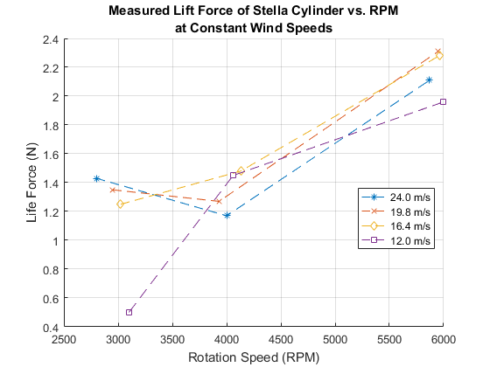

## 2. Effect of changing wind speed on lift force

## Calculating Reynolds number for 3 cylinders and all 4 speeds

speeds1to4 = [speed1,speed2,speed3,speed4];  
speeds1to5stella = [speed1,speed2,speed3,speed4,29.420];  
nu = 15.11e-6; % (m^2/s) kinematic viscosity of air at room temperature  
  
ReStella = speeds1to5stella.*(rStella*2)/nu;  
ReBud = speeds1to4.*(rBud*2)/nu;  
ReQuaker = speeds1to4.*(rQuaker*2)/nu;  
strReStella = sprintf('Re = %1.3d \n',ReStella);  
strReBud = sprintf('Re = %1.3d \n',ReBud);  
strReQuaker = sprintf('Re = %1.3d \n',ReQuaker);  
disp('Stella Reynolds Number for velocities in increasing magnitude (12.0,16.4,19.8,24.0) m/s')  
disp(strReStella)  
disp('Bud Heavy Reynolds Number for velocities in increasing magnitude (12.0,19.8,24.0) m/s')  
disp(strReBud)  
disp('Quaker Reynolds Number for velocities in increasing magnitude (12.0,16.4,19.8,24.0) m/s')  
disp(strReQuaker)

Stella Reynolds Number for velocities in increasing magnitude (12.0,16.4,19.8,24.0) m/s  
Re = 4.603e+04   
Re = 6.273e+04   
Re = 7.583e+04   
Re = 9.206e+04   
Re = 1.128e+05   
  
Bud Heavy Reynolds Number for velocities in increasing magnitude (12.0,19.8,24.0) m/s  
Re = 6.662e+04   
Re = 9.079e+04   
Re = 1.098e+05   
Re = 1.332e+05   
  
Quaker Reynolds Number for velocities in increasing magnitude (12.0,16.4,19.8,24.0) m/s  
Re = 1.020e+05   
Re = 1.389e+05   
Re = 1.680e+05   
Re = 2.039e+05

## Plotting all the data

Experiment was conducted to have approximately the same RPM. Assuming the difference in lift force from <300 RPM difference is negligible for the purpose of seeking a pattern.

speeds = [speed4,speed3,speed2,speed1];  
  
% Stella Cylinder  
figure;  
hold on;  
plot(speeds,forceStella(:,3),'--*');  
plot(speeds,forceStella(:,2),'-.x');  
plot(speeds,forceStella(:,1),'k:d');  
xlim([10 26]);  
xlabel('Wind Speeds (m/s)','FontSize',12);  
ylabel('Lift Force (N)','FontSize',12);  
title({'Effect of Wind Speed on Stella Cylinder Lift Force','Assuming Constant RPM'});  
l = legend('Location','southwest','~3000 RPM','~4000 RPM','~6000 RPM');  
%set(l,'FontSize',12);  
  
% Bud Cylinder  
figure;  
hold on;  
plot(speeds([1,3,4]),forceBud([1,3,4],3),'--*');  
plot(speeds([1,3,4]),forceBud([1,3,4],2),'-.x');  
plot(speeds([1,3,4]),forceBud([1,3,4],1),'k:d');  
xlim([10 26]);  
xlabel('Wind Speeds (m/s)','FontSize',12);  
ylabel('Lift Force (N)','FontSize',12);  
title({'Effect of Wind Speed on Bud Cylinder Lift Force','Assuming Constant RPM'});  
l = legend('Location','best','~3000 RPM','~5000 RPM','~6000 RPM');  
%set(l,'FontSize',12);  
  
% Oats Cylinder  
figure;  
hold on;  
plot(speeds,forceQuaker(:,3),'--*');  
plot(speeds,forceQuaker(:,2),'-.x');  
plot(speeds,forceQuaker(:,1),'k:d');  
xlim([10 26]);  
xlabel('Wind Speeds (m/s)','FontSize',12);  
ylabel('Lift Force (N)','FontSize',12);  
title({'Effect of Wind Speed on Oats Cylinder Lift Force','Assuming Constant RPM'});  
l = legend('Location','best','~3500 RPM','~4250 RPM','~5500 RPM');  
%set(l,'FontSize',12);

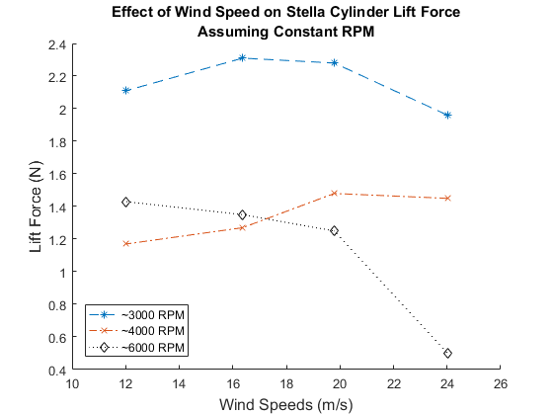

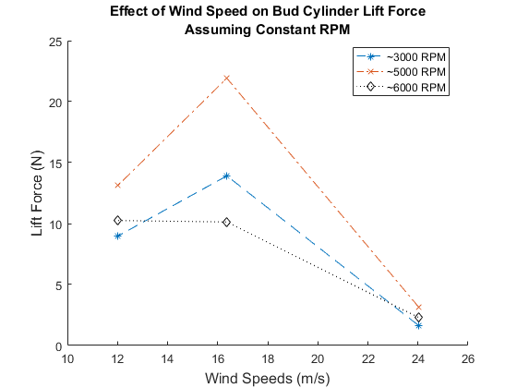

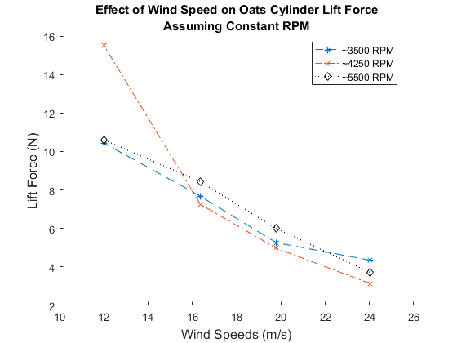

## fitting the wind speed data

stellaWindRPMfit6k = polyfit(speeds',forceStella(:,1),1);  
sWRfitx = speeds(4):(speeds(1) - speeds(4))/10:speeds(1);  
sWRfity = sWRfitx*stellaWindRPMfit6k(1) + stellaWindRPMfit6k(2);  
  
figure;  
plot(speeds,forceStella(:,1),'*',sWRfitx,sWRfity);  
xlabel('Wind Speed (m/s)','FontSize',12);  
ylabel('Lift Force (N)','FontSize',12);  
title('Lift Force vs. Wind Speed Stella Cylinder at ~6000 rpm');  
l = legend('Location','best','Data','Best Fit');  
%set(l,'FontSize',12);  
  
budWindRPMfit6k = polyfit(speeds([1,3,4])',forceBud([1,3,4],1),1);  
bWRfitx = speeds(4):(speeds(1) - speeds(4))/10:speeds(1);  
bWRfity = bWRfitx*budWindRPMfit6k(1) + budWindRPMfit6k(2);  
  
figure;  
plot(speeds([1,3,4]),forceBud([1,3,4],1),'*',bWRfitx,bWRfity);  
xlabel('Wind Speed (m/s)','FontSize',12);  
ylabel('Lift Force (N)','FontSize',12);  
title('Lift Force vs. Wind Speed Bud Cylinder ~6000 rpm');  
l = legend('Location','best','Data','Best Fit');  
%set(l,'FontSize',12);  
  
quakerWindRPMfit6k = polyfit(speeds',forceQuaker(:,1),1);  
qWRfitx = speeds(4):(speeds(1) - speeds(4))/10:speeds(1);  
qWRfity = qWRfitx*quakerWindRPMfit6k(1) + quakerWindRPMfit6k(2);  
  
figure;  
plot(speeds,forceQuaker(:,1),'*',qWRfitx,qWRfity);  
xlabel('Wind Speed (m/s)','FontSize',12);  
ylabel('Lift Force (N)','FontSize',12);  
title('Lift Force vs. Wind Speed Quaker Cylinder ~6000 rpm');  
l = legend('Location','best','Data','Best Fit');  
%set(l,'FontSize',12);

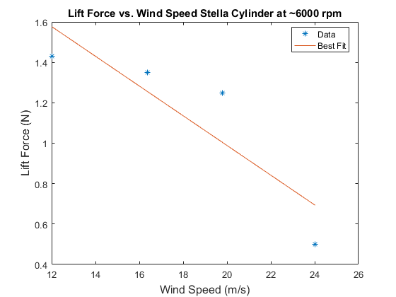

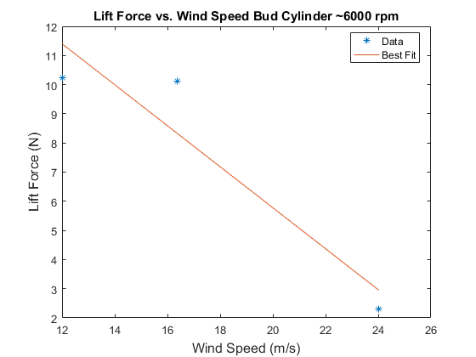

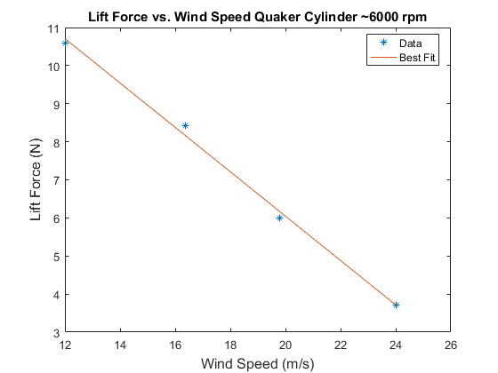

## 3. Effect of increasing wind speed on a fixed RPM on the lift force

## Plotting and fitting

windSpeed = [11.12,16.37,20.3,23.59,26.47,29.42]; % [m/s]  
liftForce = [0.67,0.61,0.5,0.4,0.36,0.47]; % [N]  
  
windForceFit = polyfit(windSpeed,liftForce,1);  
windForcex = linspace(windSpeed(1),windSpeed(end),6);  
windForcey = windForcex*windForceFit(1) + windForceFit(2);

## Error Analysis

confidence interval------------------------------------------- defining the degree of freedom and confidence interval

N = length(windSpeed);  
dF = N - (1 + 1);  
confidenceLevel = 0.975; % Matlab uses one-tail probability  
  
% finding the t score  
t = tinv(confidenceLevel,dF);  
% t = 2.3060  
  
% average value of x axis data  
xMean = mean(windSpeed);  
  
% the sum of difference of X - xbar squared  
SSxx = sum((windSpeed - xMean).^2);  
  
% finding the term of sum of difference of y axis - yfit squared  
SSres = sum((liftForce - windForcey).^2);  
  
% finding Syx  
Syx = sqrt(SSres/dF);  
  
% fit confidence interval max and min  
fitCf = t*Syx*sqrt(1/N + ((windSpeed - xMean).^2)/SSxx);  
minFitCf = windForcey - fitCf;  
maxFitCf = windForcey + fitCf;  
  
% measurement confidence interval max and min  
measCf = t*Syx*sqrt(1 + 1/N + ((windSpeed - xMean).^2)/SSxx);  
minMeaCf = windForcey - measCf;  
maxMeaCf = windForcey + measCf;  
% confidence interval ends--------------------------------------

## Plotting everythang

figure;  
plot(windSpeed,liftForce,'x',windForcex,windForcey);  
hold on;  
p1 = plot(windSpeed,minFitCf,'r:');  
p2 = plot(windSpeed,maxFitCf,'r:');  
p3 = plot(windSpeed,minMeaCf,'b--');  
p4 = plot(windSpeed,maxMeaCf,'b--');  
set(get(get(p2,'Annotation'),'LegendInformation'),...  
 'IconDisplayStyle','off');  
set(get(get(p4,'Annotation'),'LegendInformation'),...  
 'IconDisplayStyle','off');  
xlabel('Wind Speed (m/s)','FontSize',12);  
ylabel('Lift Force (N)','FontSize',12);  
title({'Experimental Lift Force vs. Wind Speed','for the Stella Cylinder'});  
l = legend('Location','best','Experiment Data','Best fit line','Confidence of Fit','Confidence of Measurement');  
%set(l,'FontSize',12);

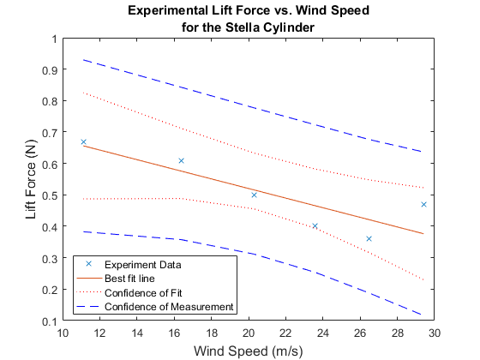

## Calculateing the Coefficient of Lift

THEORETICAL

% Below calculations were done using the equation found  
% in Tokumaru pdf  
% Note: in the document a = radius  
% CL = Lift/length*rhoair*(velocity.^2)*radius  
  
% Coeffeicient of lift for Stella  
CLthStella1 = FLStella1/(LStella*airrho*(speed1^2)*rStella);  
CLthStella2 = FLStella2/(LStella*airrho*(speed2^2)*rStella);  
CLthStella3 = FLStella3/(LStella*airrho*(speed3^2)*rStella);  
CLthStella4 = FLStella4/(LStella*airrho*(speed4^2)*rStella);  
  
% Coeffeicient of lift for Bud Heavy  
CLthBud1 = FLBud1/(LBud*airrho*(speed1^2)*rBud);  
CLthBud2 = FLBud2/(LBud*airrho*(speed2^2)*rBud);  
CLthBud3 = FLBud3/(LBud*airrho*(speed3^2)*rBud);  
CLthBud4 = FLBud4/(LBud*airrho*(speed4^2)*rBud);  
  
% Coeffeicient of lift for Oats  
CLthQuaker1 = FLQuaker1/(LQuaker*airrho*(speed1^2)*rQuaker);  
CLthQuaker2 = FLQuaker2/(LQuaker*airrho*(speed2^2)*rQuaker);  
CLthQuaker3 = FLQuaker3/(LQuaker*airrho*(speed3^2)*rQuaker);  
CLthQuaker4 = FLQuaker4/(LQuaker*airrho*(speed4^2)*rQuaker);

## Plot Theoretical Coefficent of Lift

figure  
hold on  
plot(RPMMagnusStella,CLthStella1,'-')  
plot(RPMMagnusStella,CLthStella2,'-')  
plot(RPMMagnusStella,CLthStella3,'-')  
plot(RPMMagnusStella,CLthStella4,'-')  
title('Theoretical Coefficient of Lift for Stella Cylinder')  
xlabel('Velocity (m/s)')  
ylabel('C_L')  
legend('Location','northwest','12.0 m/s','16.4 m/s','19.8 m/s','24.0 m/s')  
grid on  
  
figure  
hold on  
plot(RPMMagnusBud,CLthBud1,'-')  
plot(RPMMagnusBud,CLthBud2,'-')  
plot(RPMMagnusBud,CLthBud3,'-')  
plot(RPMMagnusBud,CLthBud4,'-')  
title('Theoretical Coefficient of Lift for Bud Heavy Cylinder')  
xlabel('Velocity (m/s)')  
ylabel('C_L')  
legend('Location','northwest','12.0 m/s','16.4 m/s','19.8 m/s','24.0 m/s')  
grid on  
  
figure  
hold on  
plot(RPMMagnusQuaker,CLthQuaker1,'-')  
plot(RPMMagnusQuaker,CLthQuaker2,'-')  
plot(RPMMagnusQuaker,CLthQuaker3,'-')  
plot(RPMMagnusQuaker,CLthQuaker4,'-')  
title('Theoretical Coefficient of Lift for Quaker Oat Cylinder')  
xlabel('Velocity (m/s)')  
ylabel('C_L')  
legend('Location','northwest','12.0 m/s','16.4 m/s','19.8 m/s','24.0 m/s')  
grid on

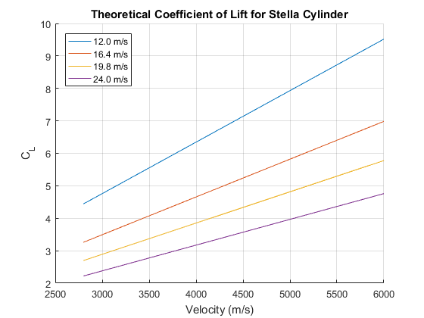

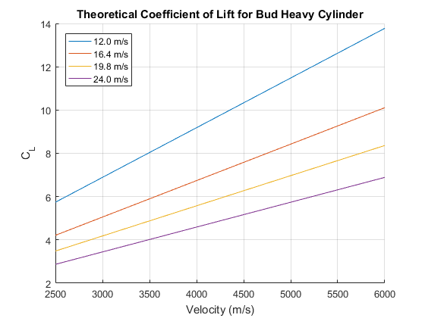

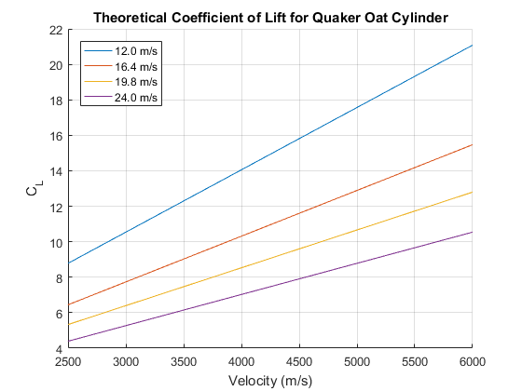

## Calculateing the Coefficient of Lift

EXPERIMENTAL

% Below calculations were done using the equation found  
% in Tokumaru pdf  
% Note: in the document a = radius  
% CL = Lift/rhoair*(velocity.^2)*radius  
  
% All speeds in order of smallest to greatest magnitude of velocity  
%speedslr = fliplr(speeds);  
  
% Coeffeicient of lift for Stella  
% Organized by trial (Constant windpeed, changing rpm)  
CLexpStella1 = forceStella(1,:)./(LStella*airrho*(speed1^2)*rStella);  
CLexpStella2 = forceStella(2,:)./(LStella*airrho*(speed2^2)*rStella);  
CLexpStella3 = forceStella(3,:)./(LStella*airrho*(speed3^2)*rStella);  
CLexpStella4 = forceStella(4,:)./(LStella*airrho*(speed4^2)*rStella);  
  
% Constant RPM and changing wind speed for Stella error analysis  
CLexpStella5 = liftForce./(LStella*airrho.*(windSpeed.^2)*rStella);  
windForceFitCL = polyfit(windSpeed,CLexpStella5,1);  
windForcexCL = linspace(windSpeed(1),windSpeed(end),6);  
windForceyCL = windForcexCL*windForceFitCL(1) + windForceFitCL(2);  
SSresCL = sum((CLexpStella5 - windForceyCL).^2);  
SyxCL = sqrt(SSresCL/dF);  
fitCfCL = t*SyxCL*sqrt(1/N + ((windSpeed - xMean).^2)/SSxx);  
minFitCfCL = windForceyCL - fitCfCL;  
maxFitCfCL = windForceyCL + fitCfCL;  
measCfCL = t*SyxCL*sqrt(1 + 1/N + ((windSpeed - xMean).^2)/SSxx);  
minMeaCfCL = windForceyCL - measCfCL;  
maxMeaCfCL = windForceyCL + measCfCL;  
  
% Coeffeicient of lift for Bud Heavy  
% Organized by trial (Constant windpeed, changing rpm)  
CLexpBud1 = forceBud(1,:)./(LBud*airrho*(speed1^2)*rBud);  
CLexpBud3 = forceBud(3,:)./(LBud*airrho*(speed3^2)*rBud);  
CLexpBud4 = forceBud(4,:)./(LBud*airrho*(speed4^2)*rBud);  
  
% Coeffeicient of lift for Oats  
% Organized by trial (Constant windpeed, changing rpm)  
CLexpQuaker1 = forceQuaker(1,:)./(LQuaker*airrho*(speed1^2)*rQuaker);  
CLexpQuaker2 = forceQuaker(2,:)./(LQuaker*airrho*(speed2^2)*rQuaker);  
CLexpQuaker3 = forceQuaker(3,:)./(LQuaker*airrho*(speed3^2)*rQuaker);  
CLexpQuaker4 = forceQuaker(4,:)./(LQuaker*airrho*(speed4^2)*rQuaker);

## Plot for Experimental Coefficient of Lift

figure  
hold on  
plot(RPMStella(1,:),CLexpStella1,'--o')  
plot(RPMStella(2,:),CLexpStella2,'--X')  
plot(RPMStella(3,:),CLexpStella3,'--*')  
plot(RPMStella(4,:),CLexpStella4,'--d')  
title('Experimental Coefficient of Lift for Stella Cylinder')  
xlabel('Cylinder Rotation Speed (RPM)')  
ylabel('C_L')  
legend('Location','northwest','12.0 m/s','16.4 m/s','19.8 m/s','24.0 m/s')  
grid on  
  
figure  
hold on  
plot(RPMBud(1,:),CLexpBud1,'--o')  
plot(RPMBud(3,:),CLexpBud3,'--X')  
plot(RPMBud(4,:),CLexpBud4,'--*')  
title('Experimental Coefficient of Lift for Bud Heavy Cylinder')  
xlabel('Cylinder Rotation Speed (RPM)')  
ylabel('C_L')  
legend('Location','northwest','12.0 m/s','19.8 m/s','24.0 m/s')  
grid on  
  
figure  
hold on  
plot(RPMQuaker(1,:),CLexpQuaker1,'--o')  
plot(RPMQuaker(2,:),CLexpQuaker2,'--X')  
plot(RPMQuaker(3,:),CLexpQuaker3,'--*')  
plot(RPMQuaker(4,:),CLexpQuaker4,'--d')  
title('Experimental Coefficient of Lift for Quaker Oat Cylinder')  
xlabel('Cylinder Rotation Speed (RPM)')  
ylabel('C_L')  
legend('Location','northwest','12.0 m/s','16.4 m/s','19.8 m/s','24.0 m/s')  
grid on  
  
figure;  
plot(windSpeed,CLexpStella5,'x',windForcexCL,windForceyCL);  
hold on;  
p1 = plot(windSpeed,minFitCfCL,'r:');  
p2 = plot(windSpeed,maxFitCfCL,'r:');  
p3 = plot(windSpeed,minMeaCfCL,'b--');  
p4 = plot(windSpeed,maxMeaCfCL,'b--');  
set(get(get(p2,'Annotation'),'LegendInformation'),...  
 'IconDisplayStyle','off');  
set(get(get(p4,'Annotation'),'LegendInformation'),...  
 'IconDisplayStyle','off');  
xlabel('Wind Speed (m/s)','FontSize',12);  
ylabel('C_L','FontSize',12);  
title({'Experimental Coefficient of Lift vs. Wind Speed','for the Stella Cylinder'});  
l = legend('Location','best','Experiment Data','Best fit line','Confidence of Fit','Confidence of Measurement');

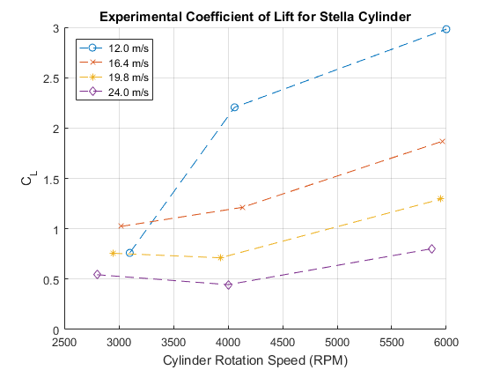

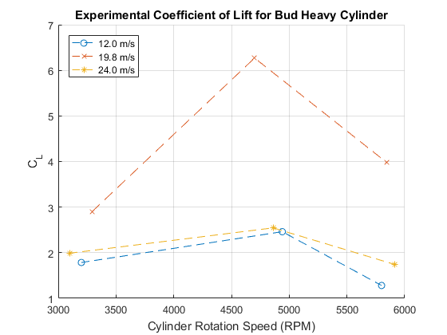

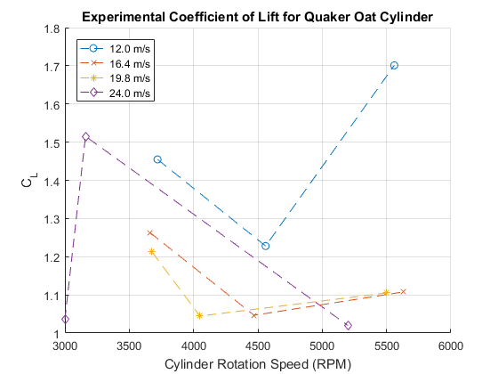

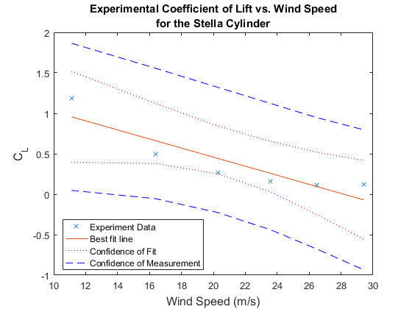

## Experimental vs Theoretical CL

CLfitStella1 = polyfit(RPMStella(1,:),CLexpStella1,1);  
CLfitStella2 = polyfit(RPMStella(2,:),CLexpStella2,1);  
CLfitStella3 = polyfit(RPMStella(3,:),CLexpStella3,1);  
CLfitStella4 = polyfit(RPMStella(4,:),CLexpStella4,1);  
bfStella1 = RPMStella(1,:)*CLfitStella1(1) + CLfitStella1(2);  
bfStella2 = RPMStella(2,:)*CLfitStella2(1) + CLfitStella2(2);  
bfStella3 = RPMStella(3,:)*CLfitStella3(1) + CLfitStella3(2);  
bfStella4 = RPMStella(4,:)*CLfitStella4(1) + CLfitStella4(2);  
  
figure  
hold on  
plot(RPMStella(1,:),CLexpStella1,'bo')  
plot(RPMStella(2,:),CLexpStella2,'rx')  
plot(RPMStella(3,:),CLexpStella3,'kd')  
plot(RPMStella(4,:),CLexpStella4,'c*')  
bf1 = plot(RPMStella(1,:),bfStella1,'b-');  
bf2 = plot(RPMStella(2,:),bfStella2,'r-');  
bf3 = plot(RPMStella(3,:),bfStella3,'k-');  
bf4 = plot(RPMStella(4,:),bfStella4,'c-');  
plot(RPMMagnusStella,CLthStella1,'b--')  
plot(RPMMagnusStella,CLthStella2,'r--')  
plot(RPMMagnusStella,CLthStella3,'k--')  
plot(RPMMagnusStella,CLthStella4,'c--')  
title({'Experimental vs Theoretical Coefficient of Lift','for the Stella Cylinder'})  
xlabel('Cylinder Rotation Speed (RPM)')  
ylabel('C_L')  
text(4000,bfStella1(3),'Experimental Best Fit line \downarrow','verticalalignment','top')  
text(3500,CLthStella1(end-3),'Dashed lines represent theoretical C_L \downarrow','verticalalignment','top')  
legend([bf1 bf2 bf3 bf4],{'12.0 m/s','16.4 m/s','19.8 m/s','24.0 m/s'},'Location','northwest')  
  
grid on

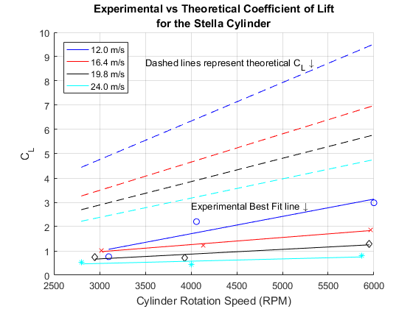

## Vortex Shedding

% Below approximation generally holds true for range of Reynolds numbers in  
% 250 < Re < 2x10^5  
  
% Strouhal Number  
StStella = 0.198*(1 - 19.7./ReStella);  
StBud = 0.198*(1 - 19.7./ReBud);  
StQuaker = 0.198*(1 - 19.7./ReQuaker);  
  
% f = St*v_wind/diameter  
% Vortex frequency  
fvStella = StStella.*speeds1to5stella/(rStella*2);  
fvBud = StBud.*speeds1to4/(rBud*2);  
fvQuaker = StQuaker.*speeds1to4/(rQuaker*2);

## Misc Info

MStoMPH = 2.23694; % m/s to mph  
  
mph1 = speed1*MStoMPH; % slowest test speed m/s to mph  
mph4 = speed4*MStoMPH; % fastest for most tests m/s to mph  
mphMAX = windSpeed(end)*MStoMPH; % Max wind speed for stella on the last test  
  
mphstr1 = sprintf('Our slowest test wind speed of %1.1f m/s = %1.1f mph',speed1,mph1);  
mphstr2 = sprintf('Our "fastest" test wind speed (for our primary tests of 3 cylinders) of %1.1f m/s = %1.1f mph',speed4,mph4);  
mphstr3 = sprintf('Our MAX test wind speed on Stella was %1.1f m/s = %1.1f mph',windSpeed(end),mphMAX);  
  
disp(mphstr1)  
disp(mphstr2)  
disp(mphstr3)

Our slowest test wind speed of 12.0 m/s = 26.9 mph  
Our "fastest" test wind speed (for our primary tests of 3 cylinders) of 24.0 m/s = 53.7 mph  
Our MAX test wind speed on Stella was 29.4 m/s = 65.8 mph

omega0_Stella1 = RPMStella(1,:)/60*2*pi*rStella/speed1;  
omega0_Stella2 = RPMStella(2,:)/60*2*pi*rStella/speed2;  
omega0_Stella3 = RPMStella(3,:)/60*2*pi*rStella/speed3;  
omega0_Stella4 = RPMStella(4,:)/60*2*pi*rStella/speed4;  
  
omega0_Quaker1 = RPMQuaker(1,:)/60*2*pi*rQuaker/speed1;  
omega0_Quaker2 = RPMQuaker(2,:)/60*2*pi*rQuaker/speed2;  
omega0_Quaker3 = RPMQuaker(3,:)/60*2*pi*rQuaker/speed3;  
omega0_Quaker4 = RPMQuaker(4,:)/60*2*pi*rQuaker/speed4;  
  
omega0 = [omega0_Stella1(1),omega0_Stella2(1:2),omega0_Stella3,omega0_Stella4,...  
 omega0_Quaker1(1:2),omega0_Quaker2,omega0_Quaker3,omega0_Quaker4];  
CLexp = [CLexpStella1(1),CLexpStella2(1:2),CLexpStella3,CLexpStella4,...  
 CLexpQuaker1(1:2),CLexpQuaker2,CLexpQuaker3,CLexpQuaker4];  
  
[omegafit,S] = polyfit(omega0.^0.3,CLexp,1);  
% R^2 values for the fit  
disp(['R^2 Value of the Fit: ',num2str(1 - S.normr^2 / norm(CLexp-mean(CLexp))^2)]);  
omega0Fit = linspace(0,3.5,100);  
% CLFit = omega0Fit.^(0.08);  
CLFit = (omega0Fit-0.3).^0.3;  
  
figure;  
hold on;  
pp4 = plot(omega0_Stella1([2,3]),CLexpStella1([2,3]),'kX');  
plot(omega0_Stella2(3),CLexpStella2(3),'kX',omega0_Quaker1(3),CLexpQuaker1(3),'kX');  
plot(omega0_Stella1(1),CLexpStella1(1),'b*');  
pp1 = plot(omega0_Stella2([1,2]),CLexpStella2([1,2]),'b*');  
plot(omega0_Stella3,CLexpStella3,'b*');  
plot(omega0_Stella4,CLexpStella4,'b*');  
  
pp2 = plot(omega0_Quaker1([1,2]),CLexpQuaker1([1,2]),'r*');  
plot(omega0_Quaker2,CLexpQuaker2,'r*');  
plot(omega0_Quaker3,CLexpQuaker3,'r*');  
plot(omega0_Quaker4,CLexpQuaker4,'r*');  
pp3 = plot(omega0Fit(9:end),CLFit(9:end),'--');  
  
box;  
  
xlabel('\Omega_0 (normalized speed)','FontSize',12);  
ylabel('C_L','FontSize',12);  
legend([pp1 pp2 pp3 pp4],...  
 {'Stella C_L','Quaker Oats C_L','Suggested Relationship','Outlaying data not considered for the fit'},...  
 'Location','southeast')

R^2 Value of the Fit: 0.39125  
Warning: Imaginary parts of complex X and/or Y arguments ignored

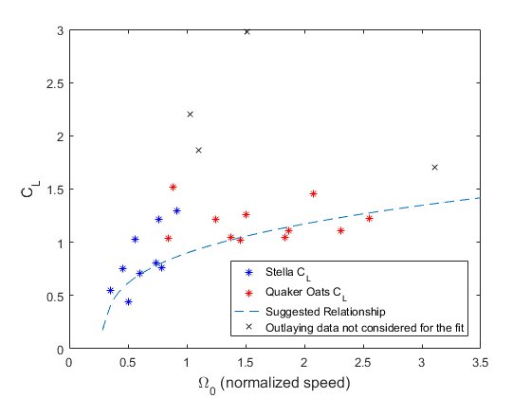

[*Published with MATLAB® R2016a*](http://www.mathworks.com/products/matlab)